Create a Git Account 1

Create a folder 1

Configure User Name 2

Configure Email 2

Generate a Key 2

Start the ssh agent in the background 3

Copy the key 3

Create a Repository 4

Paste the Key 4

Initialize Git 5

Connect to the remote repository 6

Copy the link from GitHub 6

Paste the link with the command 6

Move Files to git 6

Git Add 6

Git Commit 6

Git Push 7

# Create a Git Account

* <https://github.com/>



* Click Sign up

# Create a folder

Right Click and select Git Bash Here. Alternatively, use the mkdir command.

# Configure Username

Link for Reference:

<https://docs.github.com/en/get-started/getting-started-with-git/setting-your-username-in-git>

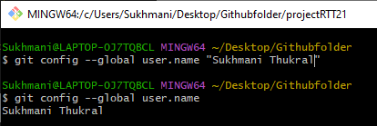

# Configure Email



# Generate a Key

**ssh-keygen -t ed25519 -C** [**your_email@example.com**](mailto:your_email@example.com)

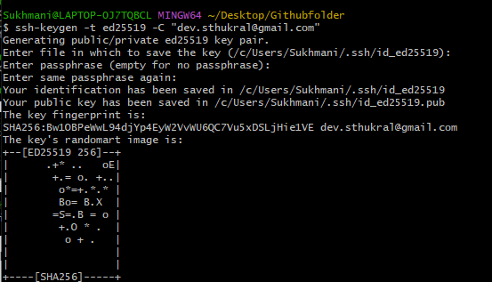

# Start the ssh agent in the background

eval "$(ssh-agent -s)"

ssh-add ~/.ssh/id_ed25519

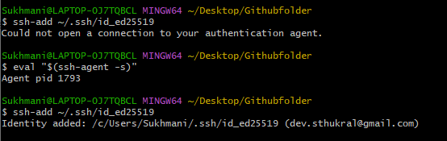

# Copy the key

clip < ~/.ssh/id_ed25519.pub

# Create a Repository

# Paste the Key



# Initialize Git

This will give you access to various folders and functions



# Connect to the remote repository

## Copy the link from GitHub

## Paste the link with the command

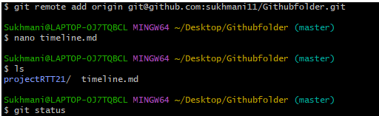

# Move Files to git

## Git Add

Git add

## Git Commit

## Git Push

Next: Branching

